Jacinta’s unit planner: Term 3, 2025
“Identity-making through Abstract Expressionism”
Refer to the accompanying educational resource HERE
Subject: Visual Arts Year level: 10
Timeframes | Relevant Australian curriculum links and documents | Resources for teaching diverse learners
1 lesson =  90 mins (2 periods)  4 lessons total  = 6 hours allocation | Framework for Improving Student Outcomes (FISO 2.0)  Visual Arts Glossary F-10  Victorian Curriculum and Assessment Authority  Independent Schools Victoria  Code of Practice for visual arts  Australian Professional Teacher Standards  Melbourne Declaration on Educational goals for Young Australians (MCEETYA, 2008)  Alice Springs (Mparntwe) Education Declaration (Education Council, 2019) | Evidence-based teaching practices (AERO)  The no language method, The Australian Institute for Teaching and School Leadership (AITSL)  Student diversity in Australian Curriculum.  Disability Standards for Education (2005)  Meeting the needs of students for whom English is an additional language or dialect  Department of Education and Training. (2017). High Impact Teaching Strategies: Excellence in Teaching and Learning. Victoria State Government  'Meeting the needs of gifted and talented students' .  Victorian Aboriginal Languages Curriculum

Inspired by the abstract and organic forms by artists such as John Clement, Hans Arp, and Richard Erdman; students explore the expressive style of abstract expressionism and the concept of ‘identity’ through hands-on construction techniques. Engaging with various mediums, experimental activities and conceptual idea generation on the theme of identity, students then create a final artwork representing an aspect of themselves. Starting with a wooden base, they drill holes to anchor welding rods, which are then bent into flowing, organic shapes inspired by their continuous line drawings and form prototypes. Women’s stockings (nylon pantyhose) are stretched over the wire framework to create a sculptural skin, which is then coated with wet plaster bandages. Once dry, the surface is refined—first with modelling clay to smooth imperfections, then with fine sandpaper to achieve a sleek finish. The final form is unified with gesso primer, then acrylic to paint their unique design and define details.
OVERVIEW OF UNIT

By the end of Year 10, students analyse how and why visual conventions, visual arts processes and materials are manipulated in artworks they create and/or experience. They evaluate how and why artists from across cultures, times, places and/or other contexts use visual conventions, visual arts processes and materials in their visual arts practice and/or artworks to represent and/or challenge ideas, perspectives and/or meaning. They evaluate how visual arts are used to celebrate and challenge perspectives of Australian identity.
Students draw on inspiration from multiple sources to generate and develop ideas for artworks. They document and reflect on their own visual arts practice. They use knowledge of visual conventions, visual arts processes and materials to create artworks that represent and/or communicate ideas, perspectives and/or meaning. They curate and present exhibitions of their own and or/others’ artworks and visual arts practice to engage audiences.

ACHIEVEMENT STANDARDS (ACARA, 2025)

Lesson sequence
Lesson # | Learning objectives  Curriculum alignment | Relevant teaching resources  Learning support | Class content  New knowledge | Visual prompts  Worked examples
Lesson 1  (90 mins)  Each lesson starts with Acknowledge-ment of Country | Content descriptor (ACARA, 2025):  AC9AVA10E01 investigate the ways that artists across cultures, times, places and/or other contexts develop personal expression in their visual arts practice to represent, communicate and/or challenge ideas, perspectives and/or meaning.  Relevant Elaborations:  “discuss and explain how artists have represented their ideas in their artworks and artist practices”  Content descriptor (ACARA, 2025):  AC9AVA10D01 experiment with visual conventions, visual arts processes and materials to refine skills and develop personal expression  Relevant Elaborations:  “interrogating multiple ways of approaching an activity; for example, using a diverse range of media to express different interpretations of the one topic, such as producing several sketches of the one object using different media with each one exploring a different emotion” | John Clement artist process video  https://www.youtube.com/watch?v=nibdGz4Z9bY  Calder-inspired form and line activity  https://www.nga.gov/educational-resources/elements-art/form  ART and MUSIC VIDEO: A guided drawing activity by listening to SOUND with Kerri Bevis (how does the music link to your visual identity, emotions?)  https://www.youtube.com/watch?v=aOGSykgrYwk  Artist: Alexander Calder  https://calder.org/introduction/  Ibram Lassaw art bio  https://www.theartstory.org/artist/lassaw-ibram/ | In-class activities:  Teacher checks in if students have engaged with online learning to prepare them for this unit  The whole class watches a brief video of abstract sculptor John Clement on how he manipulates metal to play with elements such as line and form to convey interpretive meanings.  Students engage in experimentation with line in 2D and 3D to understood how shapes become forms, inspired by the work of sculptors such as Alexander Calder, John Clement and Ibram Lassaw. (representation of different materials, techniques, culture and time periods).  Using music to stimulate imagination, students have a go at responding to diverse sounds through spontaneous line drawings (reference artist examples like Calder or Picasso).  Students gain awareness of genres of music may stir up memories, emotions and relate their own identity in some way.  Students use a framing tool or class ipad to ‘screenshot’ sections of their drawings. Students are encouraged to play with scale, tone, rhythm as they use their mark-making to generate non-representational shapes or patterns.  Students then document their favourite abstract drawings and write annotated reflections in their work folio. They must describe the feelings/emotions/parts of their identity that came up during the exercise. Pick the top 3 ideas and refine sketches in work folio.  If there is time, students may use one piece of wire to recreate their continuous line drawings- transforming lines and shapes into form to help them understand process of 2D to 3D.  Students gain confidence by practicing to manipulate the wire with pliers, skill-building preparation for making a wire armature for their final artwork.  Homework:  Students choose to research one of the three artists – Alexander Calder, John Clement and Ibram Lassaw. They must find 3 examples of their artwork and write a brief summary in their work folio on:  - How the artist’s life or culture is reflected in the works  - What visual conventions they use  - What their artistic process is | 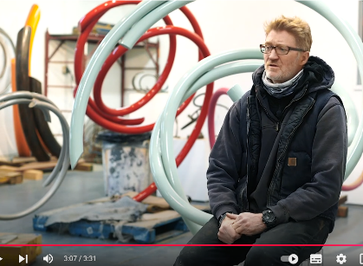  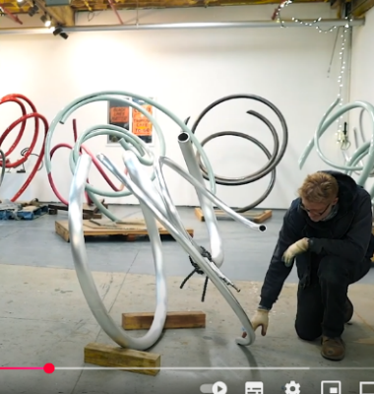  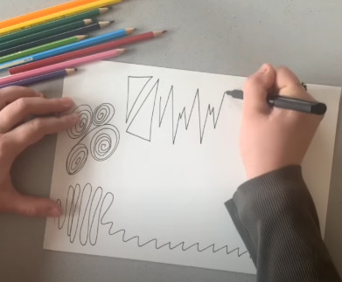  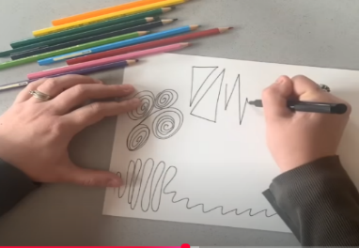  John Clement- creative practice  Abstract expression from music  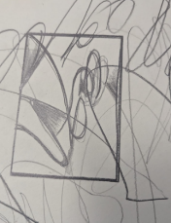  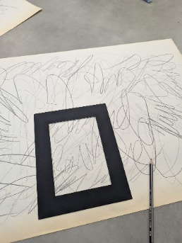  ‘Framing’ ideas  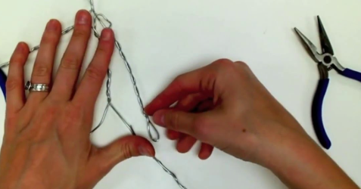  Students manipulating wire  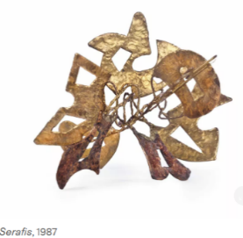  Ibram  Lassaw  Sculpture  example
Lesson 2  (90 mins)  Each lesson starts with Acknowledge-ment of Country | Content descriptor:  (ACARA, 2025):  AC9AVA10C01 evaluate critical feedback when planning, developing and refining their visual arts practice  Relevant Elaborations:  “collaborating with other students, groups or agencies, such as community groups, to generate ideas for artworks on design or artistic projects for curated exhibitions or events”  “experimenting with and evaluating ways of structuring ideas in sketches, studies, maquettes, annotated digital images or journal entries” | Tracey Lamb- Sculpture workshop https://vimeo.com/584677460  Nabilah Nordin: Making Sculptural Forms Workshop https://vimeo.com/586094105  How to Shade Basic Forms - Pencil Tutorial https://www.youtube.com/watch?v=vMr6eimcolc  Start Drawing: PART 1 - Discover Outlines, Edges and Shading - The Fundamentals of Drawing  https://www.youtube.com/watch?v=OezMavBqWXc  Learn to Draw #02 - Simplifying Objects + Learning to See  https://www.youtube.com/watch?v=nDe7kHa6MVo | In class activities:  Students participate in a collaborative class activity to generate ideas for their final artwork, work with peers for feedback/new perspectives and explore the concept of ‘identity’ further by expressing themselves to construct ‘self’. This activity is designed to teach how materiality and techniques carry meaning individually and as a collective form socially.  Students pick a coloured piece of cardboard that ‘represents’ them- what colour do you associate with representing your personality? If available, students can choose from other materialities such as corrugated paper, textured paper etc. to explore how materials and techniques can be symbolic of parts of self. Students write their own signature (identity stamp) and trace outline of it onto the cardboard to get an amorphous shape. Following a worked example to show construction techniques, students create slots into their cut-out shape.  Whilst waiting for classmates, they can decorate their piece of cardboard with patterns reflecting a hobby (nature, cooking, sport) or belief (religious, cultural, social) in black marker.  The class comes together to form one big group sculpture by connecting each students’ shapes to construct a collective form representing shared perspectives and identities merging.  Teachers facilitate a group discussion, where students take turns sharing their thoughts behind their choices and reflecting on the process. Students can view this as a verbal ‘artists statement’ .  Homework:  Students watch Nabilah Nordin’s: Making Sculptural Forms Workshop to understand creative process and artist intentions.  Students document pictures of the collective class sculpture and reflect on the process during and afterwards in their workbook. Notes must include evaluation of what worked and what didn’t work and how the activity influences their final artwork design.  Students continue to refine ideas for final artwork based on class and home activities . Upload to Google Drive before next class so teacher can provide feedback before beginning making artwork.  *Guidance on student hub for how to sketch forms | 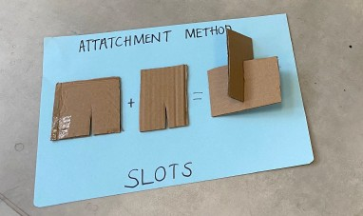  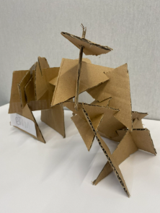  Construction  process  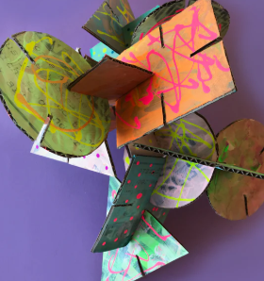  Joining amorphous shapes to create a large sculpture  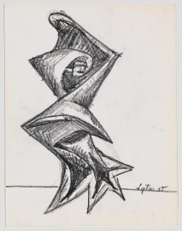  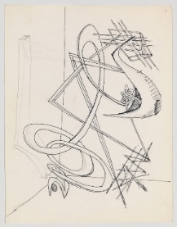  Experimental sketches to refine ideas in workbook. (example from Seymour Lipton)
Lesson 3  (90 mins) | Content descriptor:  (ACARA, 2025):  AC9AVA10C02 select and manipulate visual conventions, visual arts processes and/or materials to create artworks that reflect personal expression, and represent and/or challenge, ideas, perspectives and/or meaning  Relevant Elaborations:  “researching approaches to representing their ideas and interests in the world/subjects or concepts from a particular viewpoint or a range of viewpoints in order to plan and refine their approach”  “creating artworks that realise the intentions and communicate ideas developed through their experimentation and planning” | Wire and Nylon Sculpture Tutorial  https://www.youtube.com/watch?v=pWbJrsLYRt0  Creating Nylon structure  https://www.youtube.com/watch?v=wfZVsg4wuMY  What's the Sound of Colour? Kandinsky and Music  https://www.youtube.com/watch?v=2xDnxkzQtdI  Your colour is your superpower | Natalia Filvarova | TEDxLviv  https://www.youtube.com/watch?v=HLsYZUb3JQQ | In class activities:  Artwork making Steps 1-6 :  *Refer to Student & Teacher guides for details*  - Mark pre-cut wooden base for mounting holes  - Use Dremel tool to create holes for wires  - Use pliers to bend, manipulate and cut wire into preferred sculptural design  - Insert wire into holes and use hot glue to secure  - Tightly stretch stocking material over wire and base and secure firmly  - Students cover structure with plaster strips and place on drying rack  During the class, students must show teacher their ideas and refined sketches for their abstract sculpture in their folios so they can receive guidance as they produce their artwork  Extension activity: continue research on artists and artworks  Homework:  Students watch videos: “Kadinsky and Music” and “Colour is superpower” to gain an understanding of the psychology of colours. Students think about what colours they will use to paint with for their final form. They may have already considered this, however must justify it through annotation in work folio.  Students continue idea development and refine colours and details for their final artwork. | Making abstract sculpture  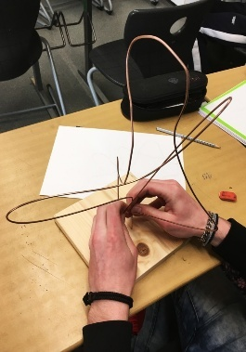  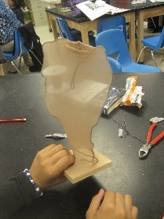  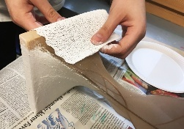  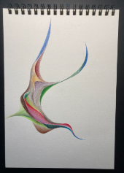  Applying colour  theory and visual  conventions to  refine colour palette  and details to be  painted over form  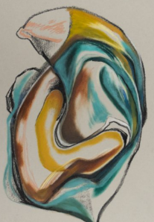  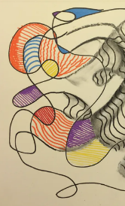
Lesson 4  (90 mins) | Content descriptor:  (ACARA, 2025):  AC9AVA10C02 select and manipulate visual conventions, visual arts processes and/or materials to create artworks that reflect personal expression, and represent and/or challenge, ideas, perspectives and/or meaning  Relevant Elaborations:  “initiating their own ways of resolving ideas and concepts visually, using creative problem-solving throughout the process of creating their final artworks”  “creating their own artworks in response to a specific subject, theme or idea, using material, techniques and conventions in intentional, interpretative and personal ways” | Abstract Cubist Stocking Sculpture  https://www.youtube.com/watch?v=wVMgC_0b1eQ  Basic Acrylic Painting Techniques for Beginners  https://www.youtube.com/watch?v=Wla7FB3Vrm0  Guide to writing an artist statement  https://theartofeducation.edu/2015/09/use-this-flowchart-to-help-your-students-write-authentic-artist-statements/ | In-class activities:  Artwork making Steps 7-9 :  *Refer to Student & Teacher guides for details*  - Sand sculpture to smooth plaster edges and define form  - Prime sculpture with gesso and dry  - Use acrylic paint to add colour and detail to final piece  Students document the process so they can annotate and reflect afterwards.  Extension activity: students work on their artist statement and catch up on any folio work.  Homework:  Students come up with an artist statement to go with final work.  Students add in pictures of creative process and annotate in workbook, ensuring to justify how their sculpture reflects part of their identity.  Students complete reflection sheet provided by teacher | 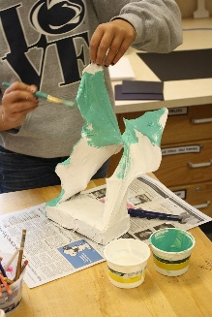  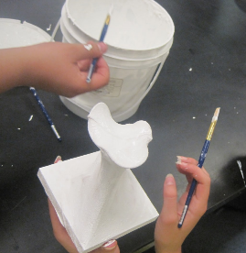  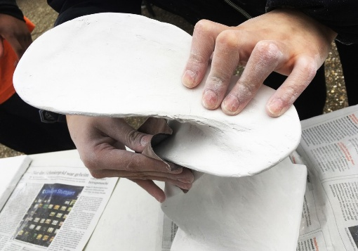  Making abstract sculpture

